PRESIDENTS’S OFFICE REGIONAL ADMINISTRATION AND LOCAL GOVERNMENT
GEITA TOWN COUNCIL
FORM FOUR PRE-MOCK EXAMINATION MAY 2022
013 GEOGRAPHY TIME 3:00 HRS
INSTRUCTIONS
- This paper consists of Sections A, B and C with a total of ten (10) questions
- Answer all questions in sections A and B, and only two (2) questions from section C
- Map extract of HANANG (Sheet 84/4) is provided
- Any unauthorized materials are not allowed in the examination room
- Write your examination number on every page of the answer sheet
SECTION A (15 Marks)
Answer all questions from this section
- For each of the items (i)-(x) choose the correct answer from the given alternatives and then write its letter beside the item number in the answer sheet (s) provided
- Suppose you are asked to identify the atmospheric layers in which their temperature characteristic is to decrease with the increase in altitude. Which among the following layers will you suggest?
A: Troposhere and Mesoshere
B: Troposhere and Mesoshere
C: Mesoshere and Ionoshere
D: Troposhere and Stratoshere
E: Stratoshere and Thermoshere
- John was wondering the way the rock peels its outer layer like an onion. What is the term for such process?
A: Block disintergration
B: Granular disintergration
C: Alternate wet and dry
D: Exfoliation
E: Frost action

- Senegal national team scored a goal at 2:00 pm in Senegal (150°W). At what time at Burundi (30°E) the goal was scored?
A: 2:00 am B: 10:00am C: 12:00am D: 4:00am E: 10:00pm

- In the field study students were told that, soil has certain biological, chemical and physical characteristics. What is the general term for these characteristics?
A: Soil profile
B: Soil particles
C: Soil properties
D: Soil fertility
E: Soil formation
- The tourists visited Amazon and Congo basins and they observed that both Amazon and Congo basins share the same background to human activities, climate and vegetation. What could be the general term for these regions?
A: Natural region
B: Natural resource
C: Natural vegetation
D: Natural climate
E: Natural landscape
- After learning different features produced from marine erosion and deposition, students were asked to identify the feature which is resulted from marine erosion. What will be picked by students who understood the lesson?
A: Sand bars
B: Tombolo
C: Geo
D: Beach
E: Spit
- Mary viewed the seasonal variation of water volume in Pangani river channel. What is the name applied to such situation?
A: River rejuvenation
B: River capture
C: River meanders
D: Graded river
E: River regime
- Summer solstice on 21st June each year means that the sun is overhead at;
A: Equator
B: Tropicof cancer
C: Tropic of Capricon
D: Artic circle
E: Antarctic circle
- Suppose you are asked to help a form one student who failed to identify features of ocean floor. Which features among the following will you suggest?
A: Basin, Ocean deep and Cliff
B: Trench, Continental shelf and stump
C: Trench, Ridge and Continental shelf
D: Ocean deep, continental shelf and Drumlin
E: Basin, Continental shelf and Tombolo
- The earth is subjected to both internal and external forces. Which of the following is associated with eruption of molten materials onto the earth surface?
A: Vulcanism
B: Volcanism
C: Earthquake
D: Folding
E: Faulting

- Match the items in List A with the response in List B by writing the letter of the corresponding response beside the item number in the answer sheet (s) provided
LIST A | LIST B
- Projecting ridges extending from alternate sides of a river bank  - Heavy materials deposited by flood along the river bank  - A cut-off of the neck of the river meander formed when flood breaks through the bends of river channel  - A tributary that flows alongside the main river for a long distance before joining the main river  - A depression formed at the base of the waterfall | A: Natural levees  B: Flood plain  C: Interlocking spurs  D: Plunge pool  E: waterfall  F: Yazoo stream  G: Ox-bow lake

SECTION B (55 Marks)
Answer all questions from this section
- Carefully study the map extract of HANANG (Sheet 84/4) provided, then answer the following questions
- Find the forward bearing and back bearing of grid reference 720220 to grid reference 680180
- Suggest with evidence four (4) major economic activities which might take place in the area.
- Giving three evidences from the map, suggest the climate of the mapped area
- Mention three factors which affect the content of the given map
- In which hemisphere does the mapped area found? (give one reason)

- Carefully study the following statistical data showing crops production in tones (000) in Tanzania from 2017 to 2020, then answer the questions that follow;
YEARS/CROPS | Maize | Beans | Rice
2017 | 30 | 25 | 70
2018 | 70 | 50 | 75
2019 | 70 | 40 | 60
2020 | 50 | 35 | 50
- Present the given data by using compound bar graph
- Give two (2) merits and demerits of the graph drawn in (a) above
- Explain the reasons for crop production in 2017 and 2020. Give two (2) reasons

- Mercy and Mary are living near Ruaha river, they used to wonder when they were observing seasonal variation of water volume in the river Ruaha channel, such that there was low amount of water to some seasons
- Give the general term used for that seasonal variation of water volume in Ruaha river channel
- Briefly explain five factors affecting the situation named in (a) above (5 points)

- Following the current mass failure of female students in the national examinations, the ministry of the President’s Office Regional Administration and Local Government (PO-RALG) committedly has decided to conduct a research on causes as well as measures to rescue the worse condition of mass failure of female students in Tanzania
- Suggest suitable research problem
- Give two (2) main objectives of this research
- With two reasons, suggest the suitable type of research
- Outline two research tools which might be applied in this research
- With clear statement, develop one alternative hypothesis and one null hypothesis on the research topic.

- Carefully study the following photograph and then answer the questions that follows;
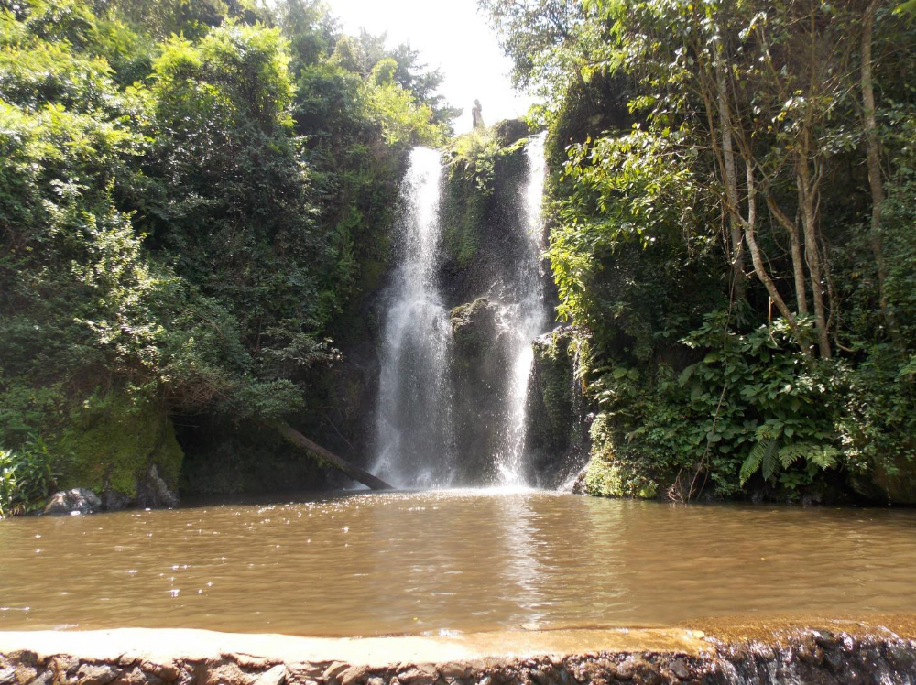
- With two reasons, comment on the type of climate
- Name the type of photograph (give two resons)
- Examine four economic activities which might be carried out in the represented area
- What is the type of the rock found on the photograph? (give two reasons)

SECTION C (30 Marks)
Answer only two (02) questions in this section
- Mining industry is very potential for economic growth in developing country like Tanzania. Justify this statement by providing six (6) points
- Tanzania conducts a census after every ten years. Using three (3) points explain to your villagers the importance of census and three (3) challenges of conducting a census.
- In Kakola village there was a land conflict over the open space. The village chairperson decided to invite a survey team to determine boundaries and land size by using chain survey.
- Describe three (3) steps the survey team went through when conducting chain survey
- Explain five pre-survey activities they need to consider.

